|  |
| --- |
| **NATIONAL UNIVERSITY OF SCIENCES AND TECHNOLOGY (NUST)** |
|  |
| **SCHOOL OF ELECTRICAL ENGINEERING AND COMPUTER SCIENCE (SEECS)** |
| EC-303 Mobile Application Development for Small and Medium Enterprises |
| LAB-05  Widgets, Complex Interfaces using stateless widget & passing context |

HAMNA NAVEED

346470

BESE-11 A

**Task # 1**

Follow the guidelines mentioned in [https://codelabs.developers.google.com/codelabs/mdc-101-flutter - 0](https://codelabs.developers.google.com/codelabs/mdc-101-flutter#0) and follow the step-by-step tutorial.

**Code**

**login.dart page**

import 'package:flutter/material.dart';  
  
class LoginPage extends StatefulWidget {  
 const LoginPage({Key? key}) : super(key: key);  
  
 @override  
 _LoginPageState createState() => _LoginPageState();  
}  
  
class _LoginPageState extends State<LoginPage> {  
 // *TODO: Add text editing controllers (101)* final _usernameController = TextEditingController();  
 final _passwordController = TextEditingController();  
 @override  
 Widget build(BuildContext context) {  
 return Scaffold(  
 body: SafeArea(  
 child: ListView(  
 padding: const EdgeInsets.symmetric(horizontal: 24.0),  
 children: <Widget>[  
 const SizedBox(height: 80.0),  
 Column(  
 children: <Widget>[  
 Image.asset('assets/diamond.png'),  
 const SizedBox(height: 16.0),  
 const Text('SHRINE'),  
 ],  
 ),  
 const SizedBox(height: 120.0),  
 // *TODO: Remove filled: true values (103)* // *TODO: Add TextField widgets (101)* // *TODO: Add TextField widgets (101)*// [Name]  
 TextField(  
 controller: _usernameController,  
 decoration: const InputDecoration(  
 filled: true,  
 labelText: 'Username',  
 ),  
 ),  
// spacer  
 const SizedBox(height: 12.0),  
// [Password]  
 TextField(  
 controller: _passwordController,  
 decoration: const InputDecoration(  
 filled: true,  
 labelText: 'Password',  
 ),  
 obscureText: true,  
 ),  
  
 // *TODO: Add button bar (101)* OverflowBar(  
 alignment: MainAxisAlignment.end,  
 // *TODO: Add a beveled rectangular border to CANCEL (103)* children: <Widget>[  
 // *TODO: Add buttons (101)* TextButton(  
 child: const Text('CANCEL'),  
 onPressed: () {  
 // *TODO: Clear the text fields (101)* _usernameController.clear();  
 _passwordController.clear();  
 },  
 ),  
 // *TODO: Add an elevation to NEXT (103)* // *TODO: Add a beveled rectangular border to NEXT (103)* ElevatedButton(  
 child: const Text('NEXT'),  
 onPressed: () {  
 // *TODO: Show the next page (101)* Navigator.*pop*(context);  
 },  
 ),  
 ],  
 ),  
 ],  
 ),  
 ),  
 );  
 }  
}

**home.dart page**

// Copyright 2018-present the Flutter authors. All Rights Reserved.  
//  
// Licensed under the Apache License, Version 2.0 (the "License");  
// you may not use this file except in compliance with the License.  
// You may obtain a copy of the License at  
//  
// http://www.apache.org/licenses/LICENSE-2.0  
//  
// Unless required by applicable law or agreed to in writing, software  
// distributed under the License is distributed on an "AS IS" BASIS,  
// WITHOUT WARRANTIES OR CONDITIONS OF ANY KIND, either express or implied.  
// See the License for the specific language governing permissions and  
// limitations under the License.  
  
import 'package:flutter/material.dart';  
  
class HomePage extends StatelessWidget {  
 const HomePage({Key? key}) : super(key: key);  
  
 // *TODO: Make a collection of cards (102)* // *TODO: Add a variable for Category (104)* @override  
 Widget build(BuildContext context) {  
 // *TODO: Return an AsymmetricView (104)* // *TODO: Pass Category variable to AsymmetricView (104)* return const Scaffold(  
 // *TODO: Add app bar (102)* // *TODO: Add a grid view (102)* body: Center(  
 child: Text('You did it!'),  
 ),  
 // *TODO: Set resizeToAvoidBottomInset (101)* resizeToAvoidBottomInset: false,  
 );  
 }  
}

**main.dart**

import 'package:flutter/material.dart';  
  
import 'app.dart';  
  
void main() => runApp(const ShrineApp());

**Output**

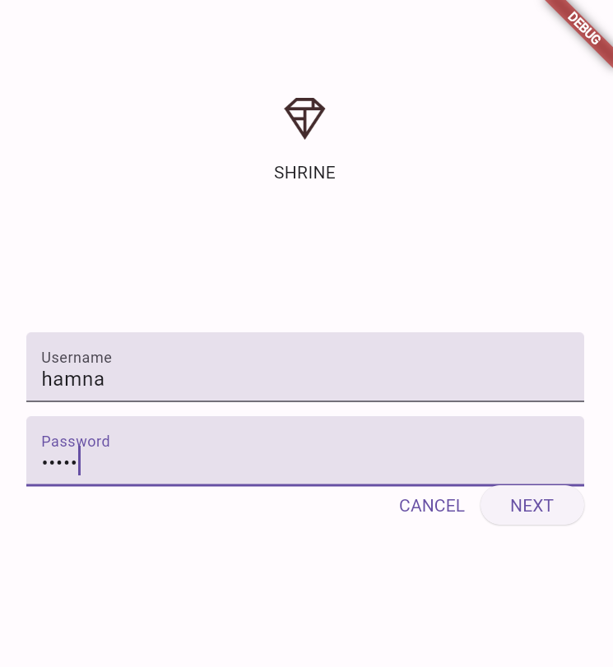

When cancel pressed

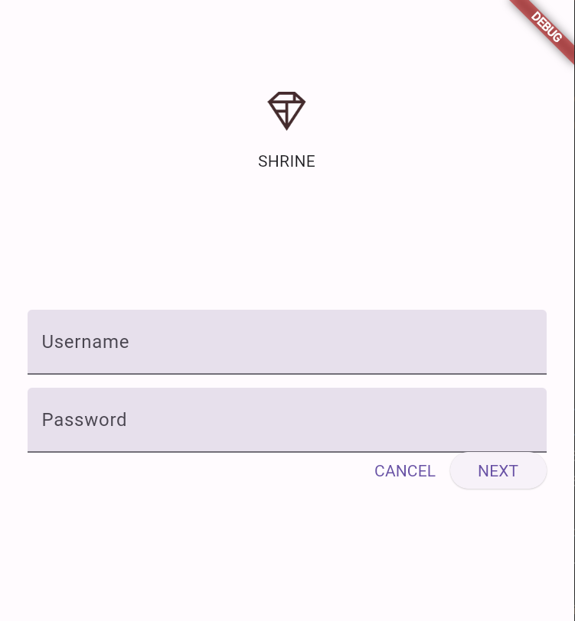

When next pressed

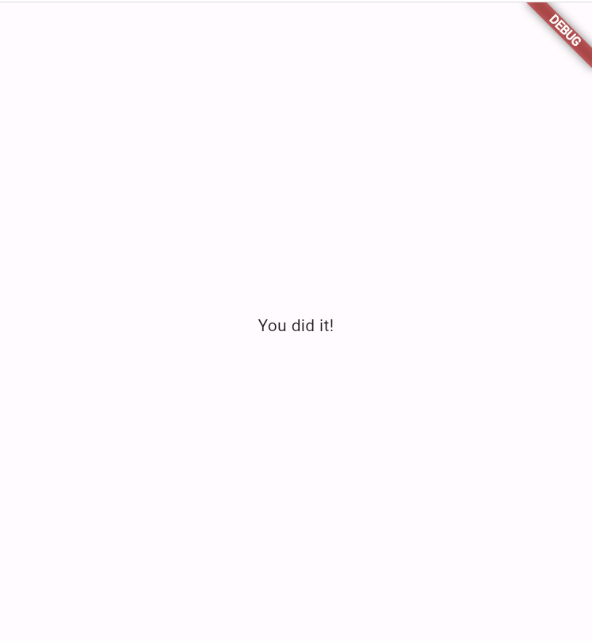

**GitHub Link**

**https://github.com/hamna456/Flutter-Lab-4/tree/main/task1/material-components-flutter-codelabs/mdc_100_series**

**Task # 2**

**Initial State when the Project clone**

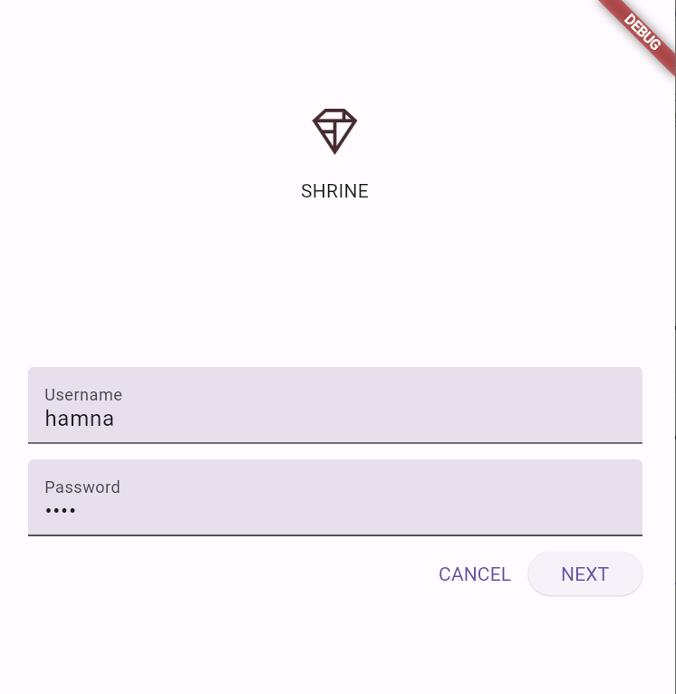

**On pressing next**

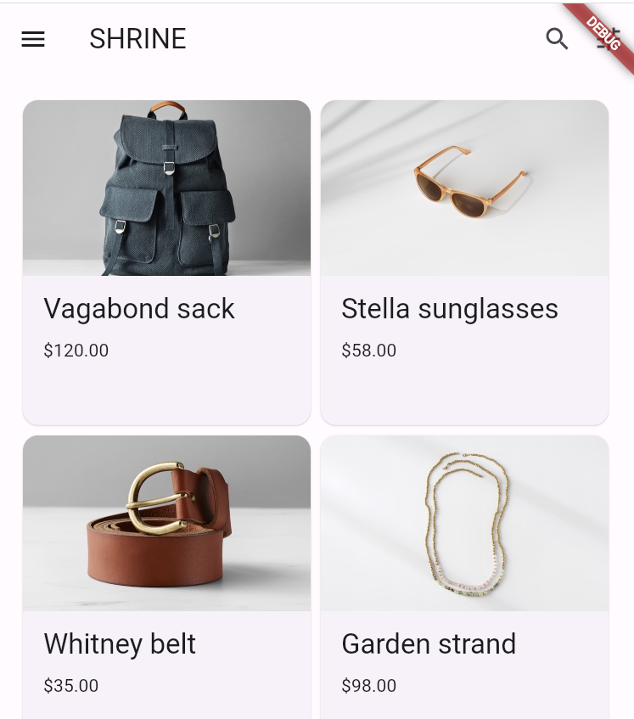

**Step 4: Change the Colors**

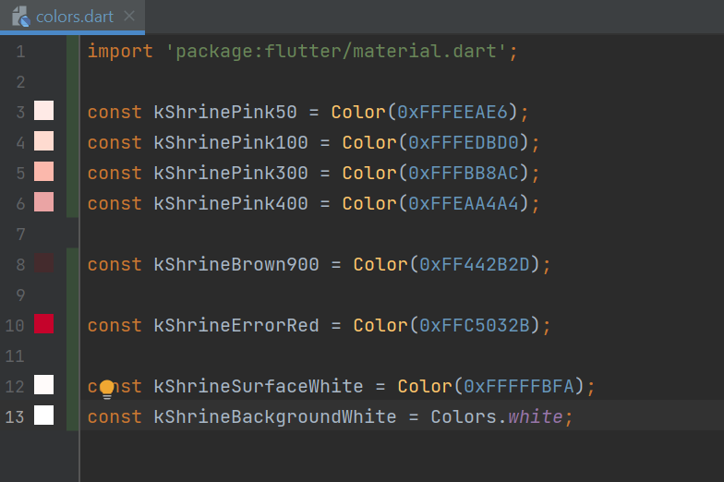

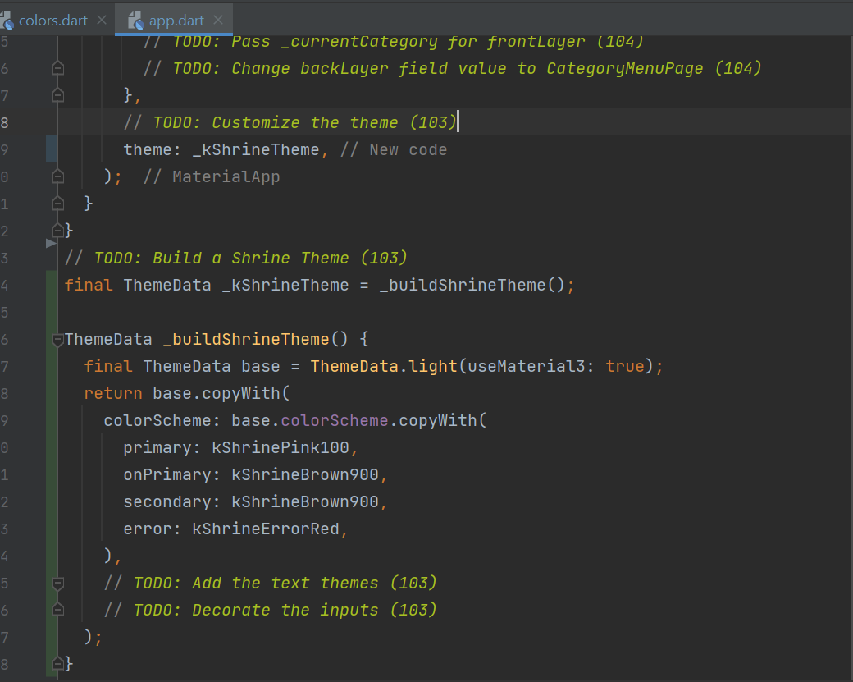

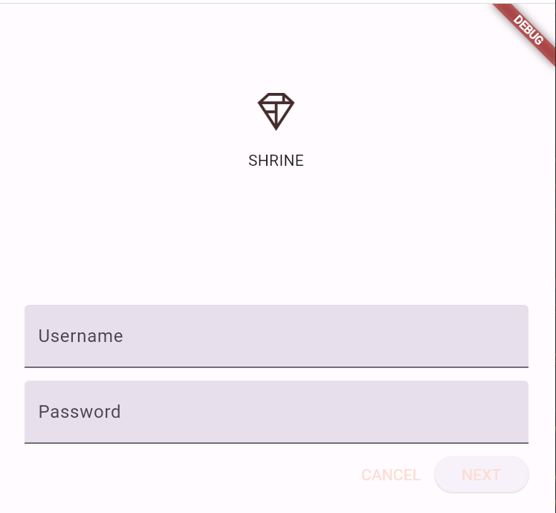

**Step 5: Modify Typography and Label Styles**

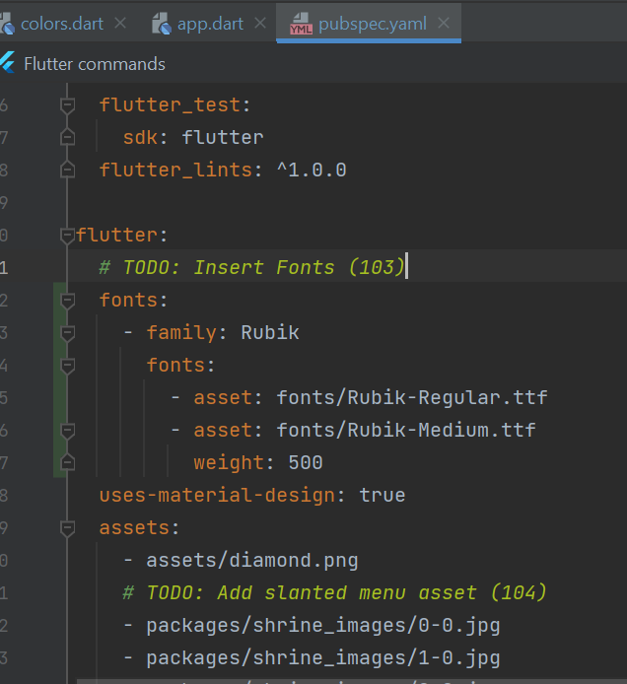

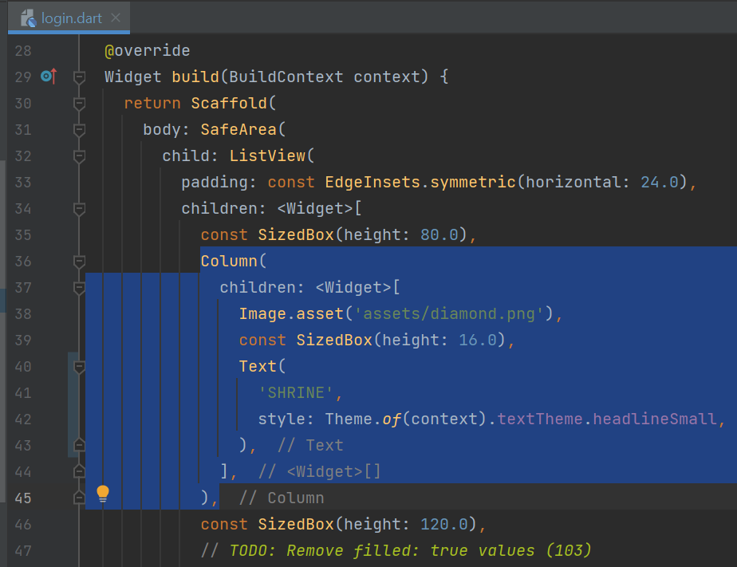

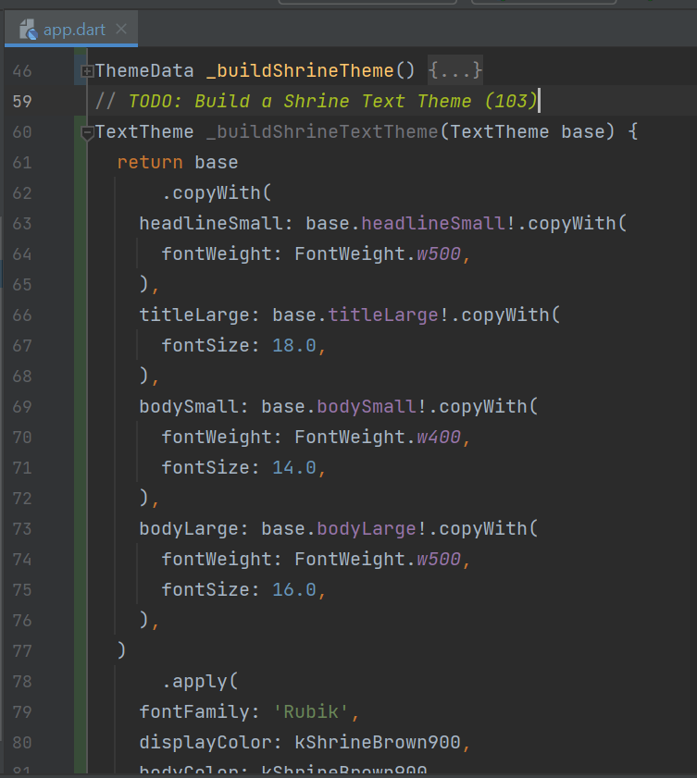

## **Use the new text themes**

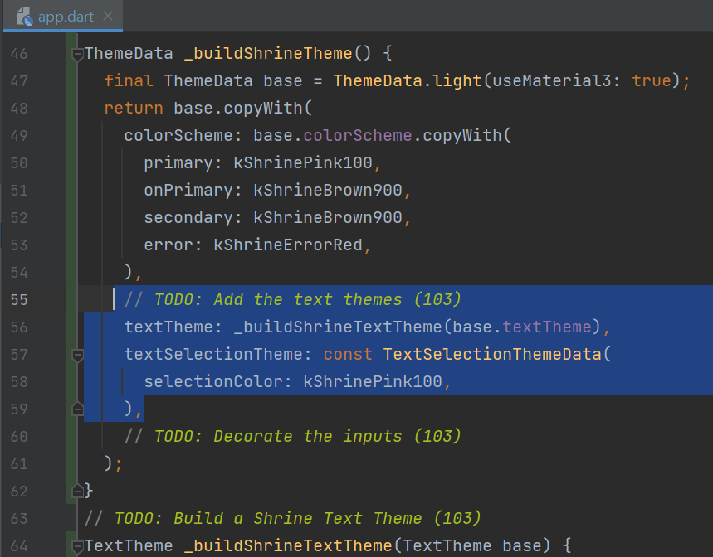

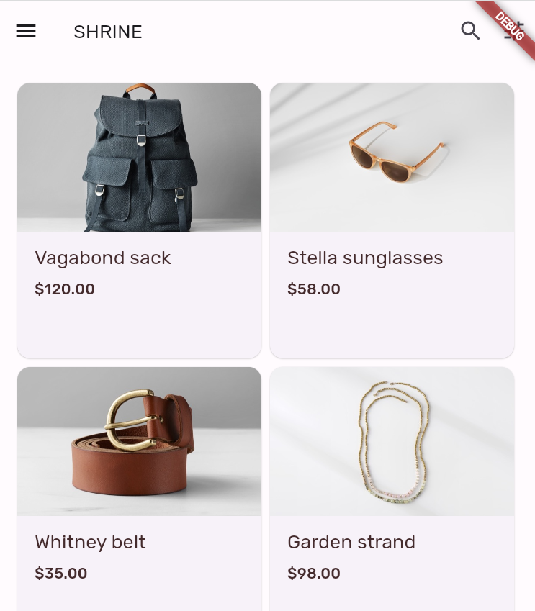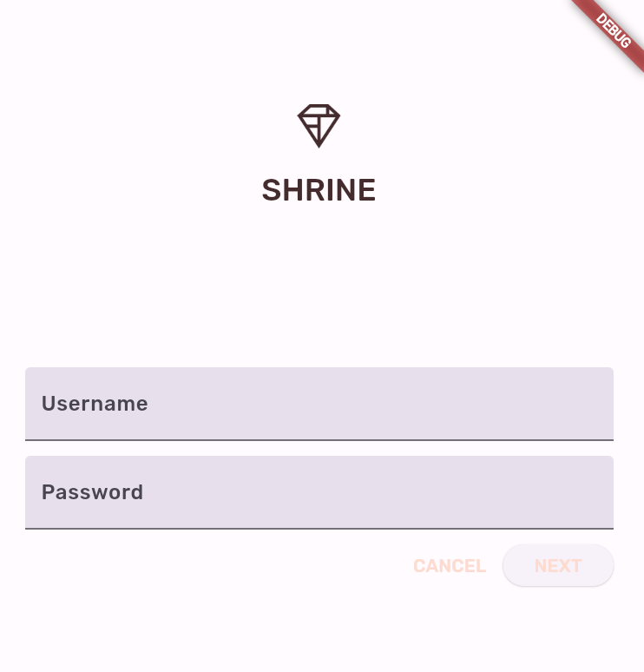

## **Shrink the text and Center and drop the text**

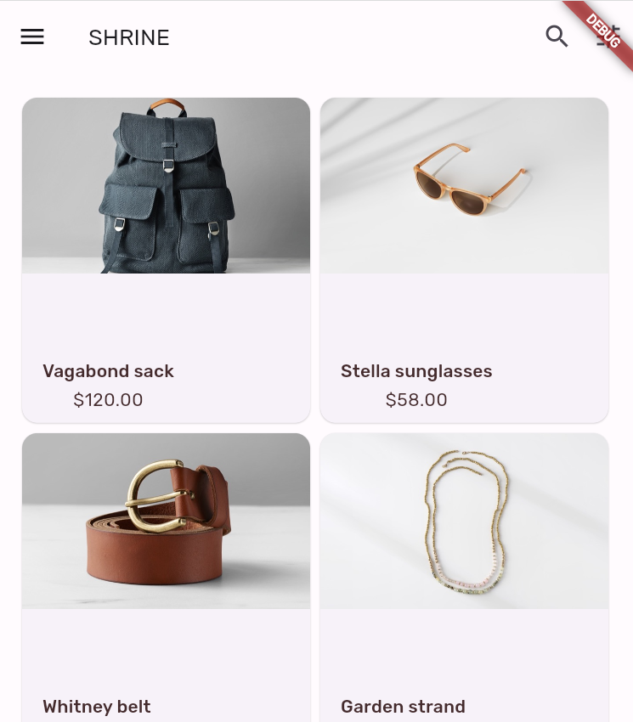

## **Theme the text fields & End look of step 5**

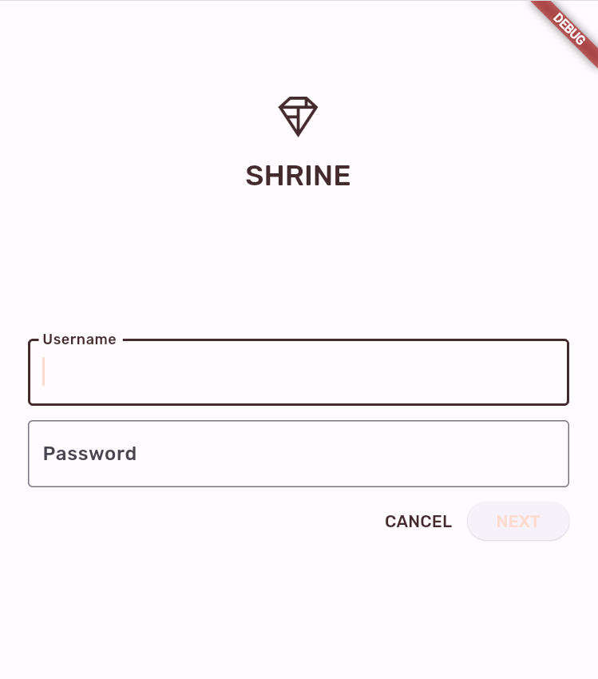

**Step 6: Adjust Elevation**

## **Change the elevation of the NEXT button**

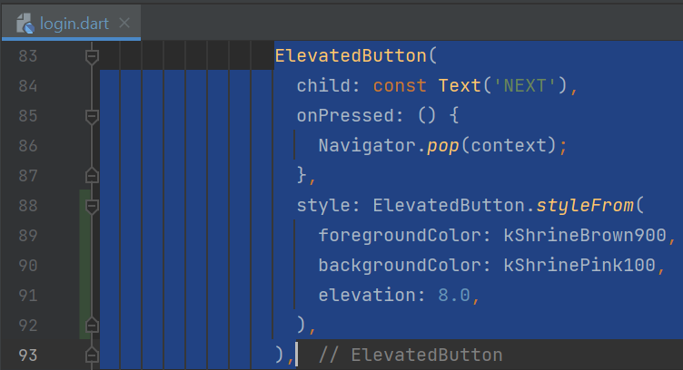

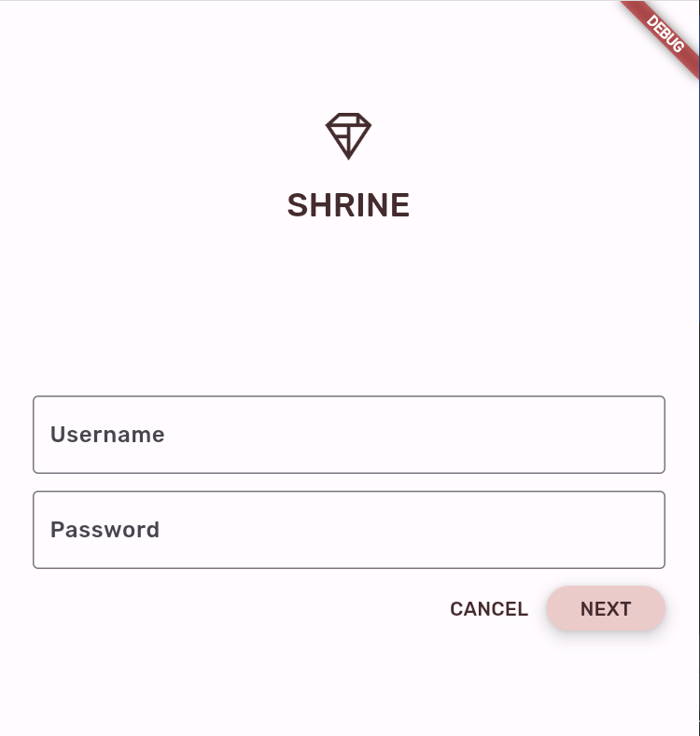

## **Adjust Card elevation**

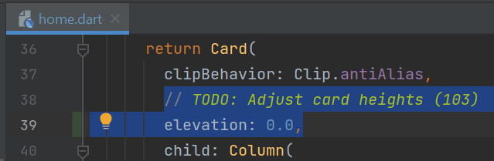

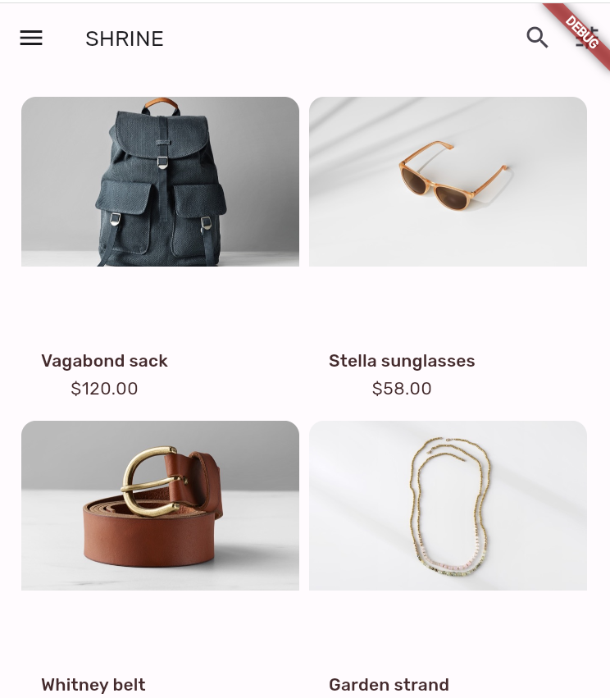

**Step 7: Add Shape**

## **Change the text field shapes on the login screen**

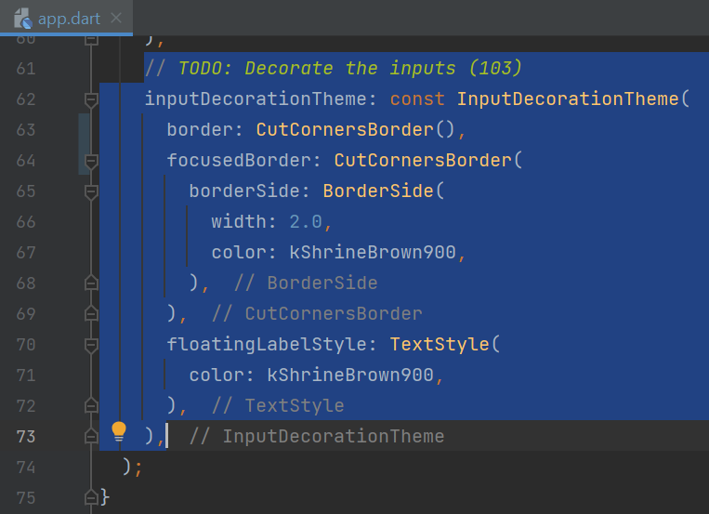

## **Change button shapes on the login screen**

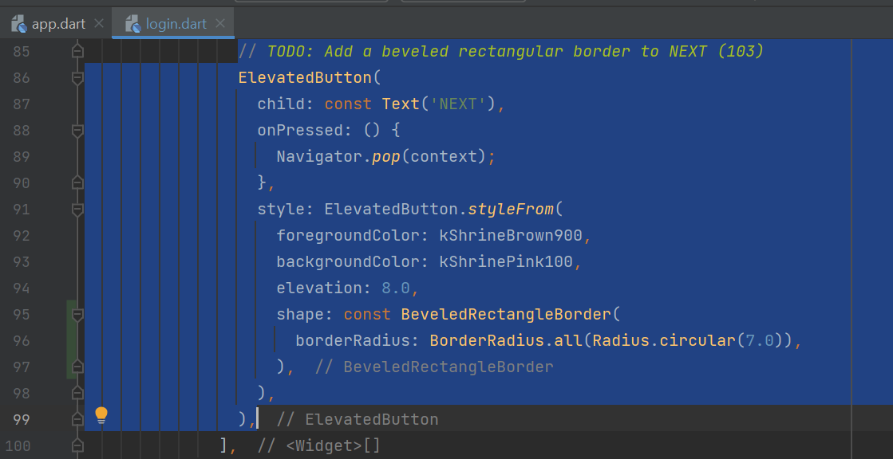

## **End look of Step 7**

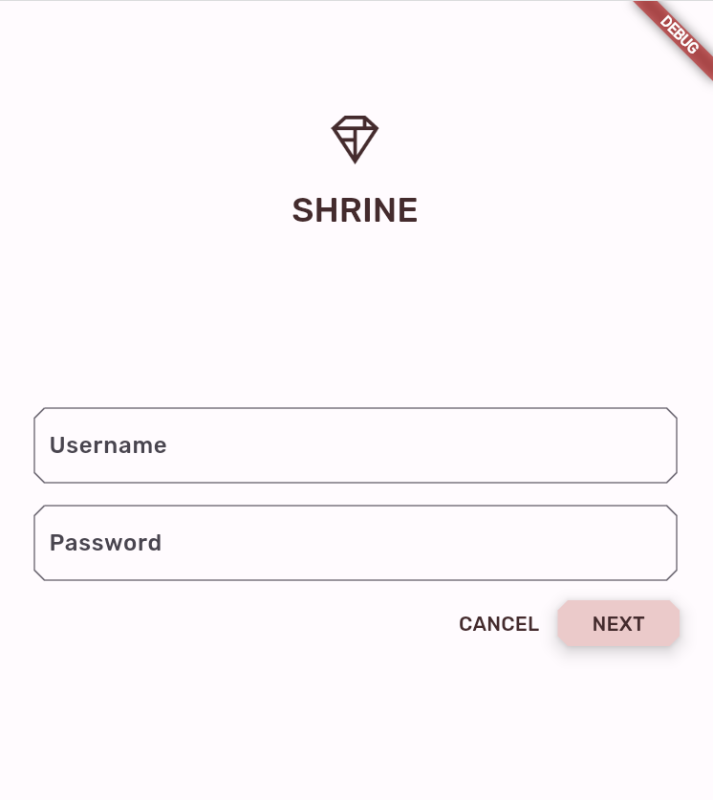

**Step 8: Change the Layout**

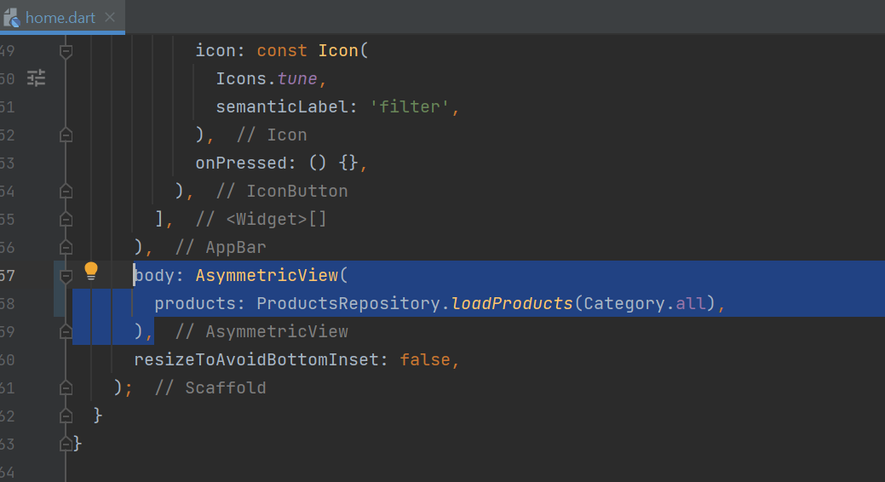

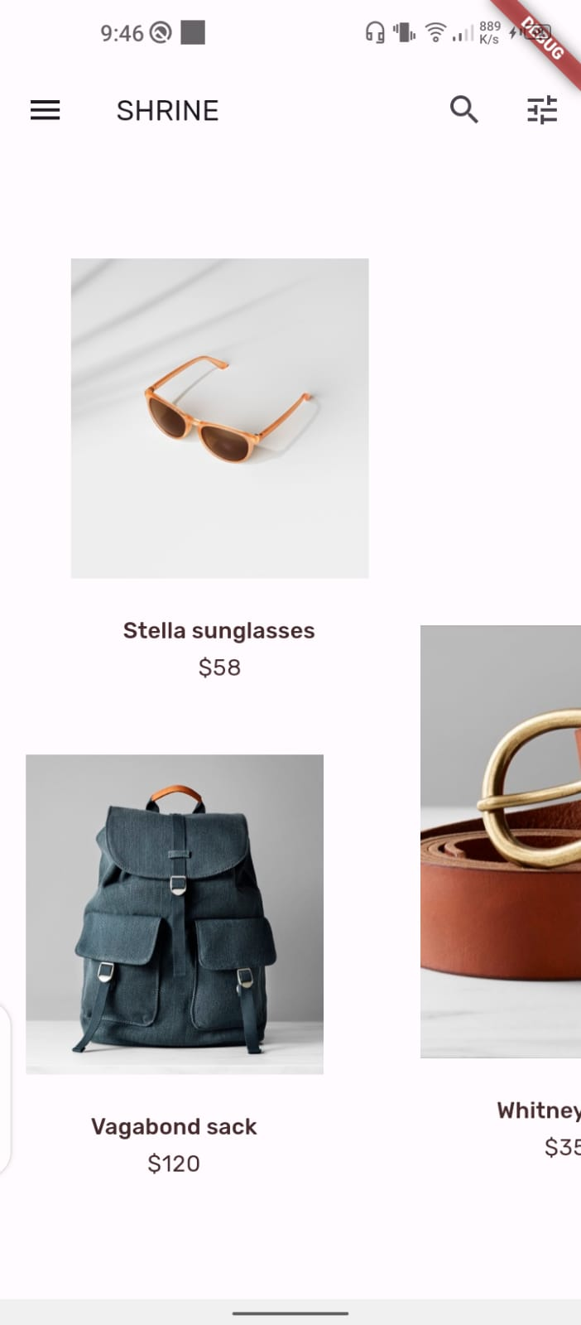

**Step 9: Try another theme**

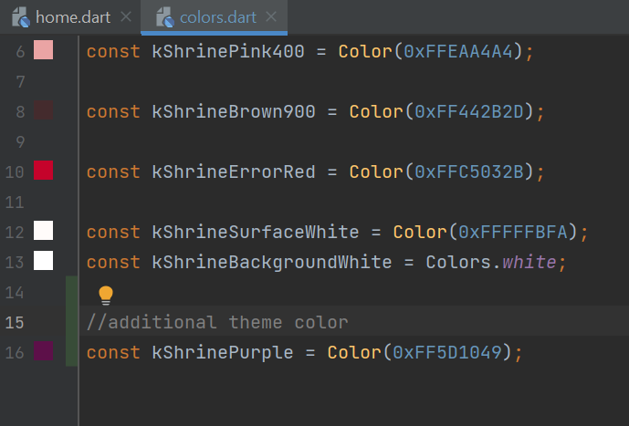

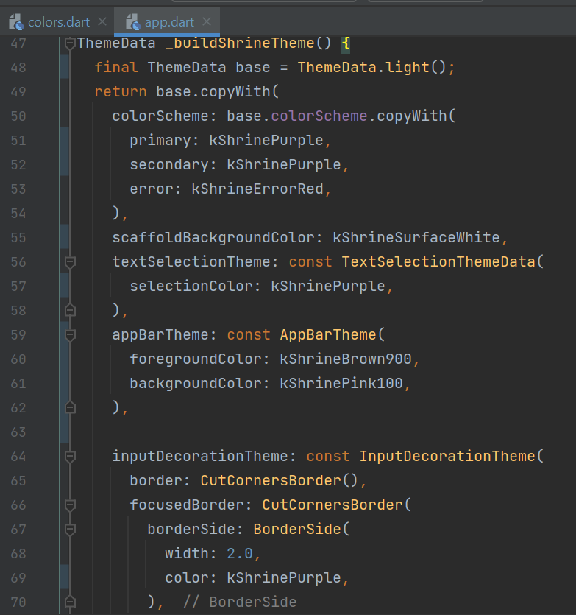

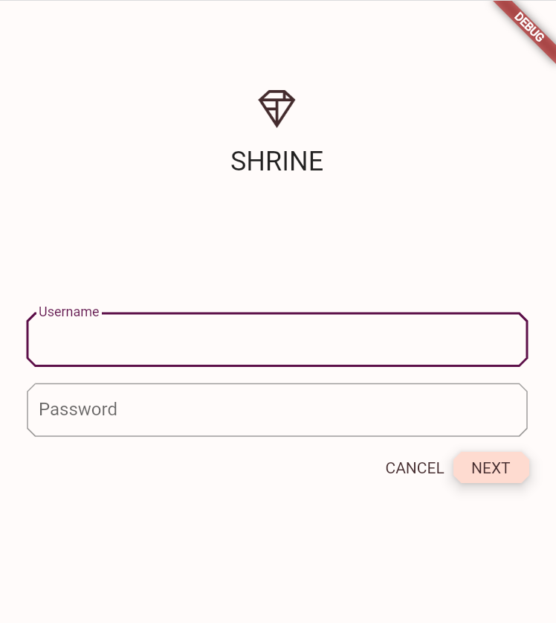 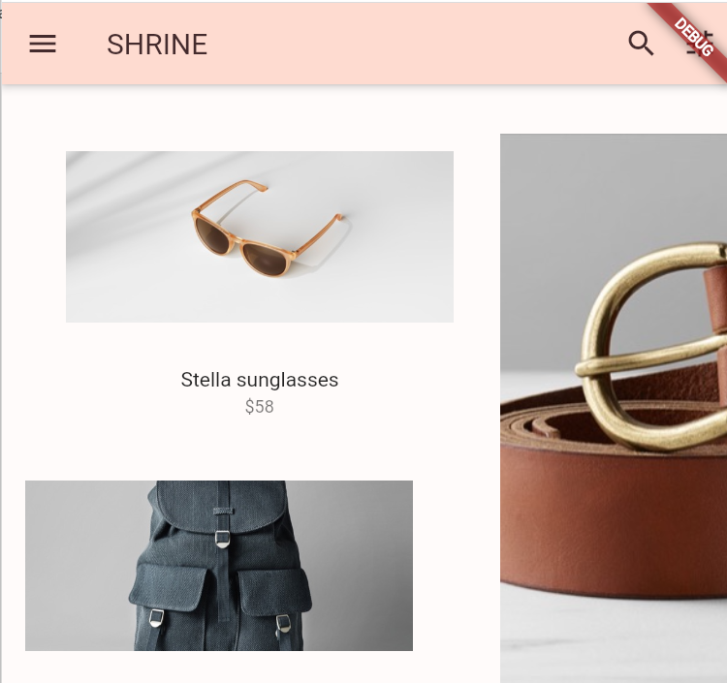

**GitHub Link**

**https://github.com/hamna456/Flutter-Lab-4/tree/main/task2/material-components-flutter-codelabs-103-starter_and_102-complete**

**Task # 3**

## Create a given widget tree - You may use to get any kind of Icons : [**https://icons8.com/icons**](https://icons8.com/icons)

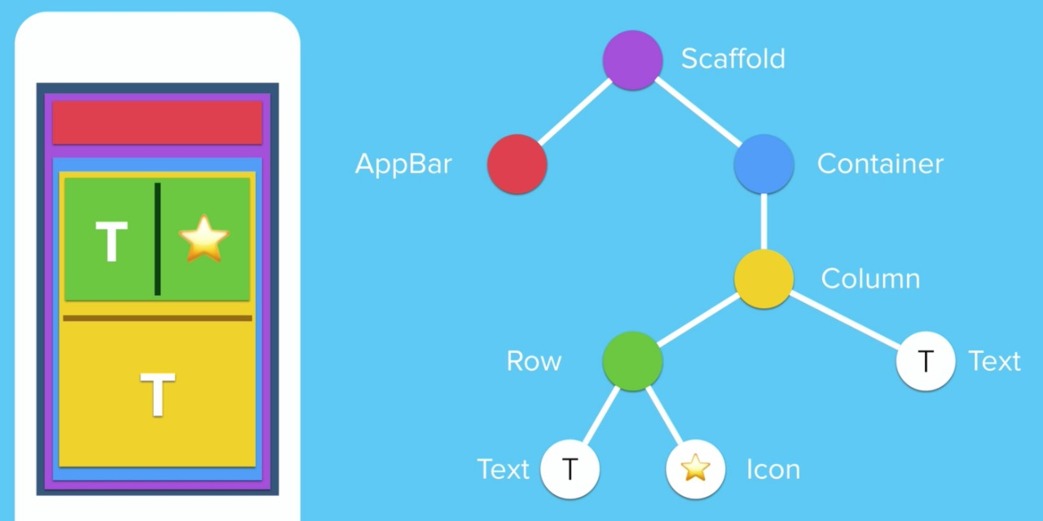

**Code**

import 'package:flutter/material.dart';  
  
void main() {  
 runApp(MyApp());  
}  
  
class MyApp extends StatelessWidget {  
 @override  
 Widget build(BuildContext context) {  
 return MaterialApp(  
 home: Scaffold(  
 backgroundColor: Colors.*blue*,  
 appBar: AppBar(  
 title: Text('Task 3'),  
 backgroundColor: Colors.*indigo*,  
 ),  
 body: Padding(  
 padding: EdgeInsets.symmetric(horizontal: 10.0),  
 child: Container(  
 color: Colors.*lightBlueAccent*,  
 padding: EdgeInsets.all(10.0),  
 child: Column(  
 crossAxisAlignment: CrossAxisAlignment.start,  
 mainAxisAlignment: MainAxisAlignment.spaceEvenly,  
 children: [  
 Expanded(  
 child: Row(  
 mainAxisAlignment: MainAxisAlignment.spaceBetween,  
 children: [  
 Text(  
 'Hamna Naveed',  
 style: TextStyle(  
 color: Colors.*black*,  
 fontSize: 32.0,  
 fontWeight: FontWeight.*bold*),  
 ),  
 Icon(  
 Icons.*person*,  
 color: Colors.*indigo*,  
 size: 42.0,  
 ),  
 ],  
 ),  
 ),  
 Divider(),  
 // Wrap the text with Center widget to center align it  
 Center(  
 child: Text(  
 'BESE-11A , 346470',  
 style: TextStyle(  
 color: Colors.*purple*,  
 fontSize: 24.0,  
 fontWeight: FontWeight.*bold*),  
 textAlign: TextAlign.center,  
 ),  
 ),  
 ],  
 ),  
 ),  
 ),  
 ),  
 );  
 }  
}

**Output**

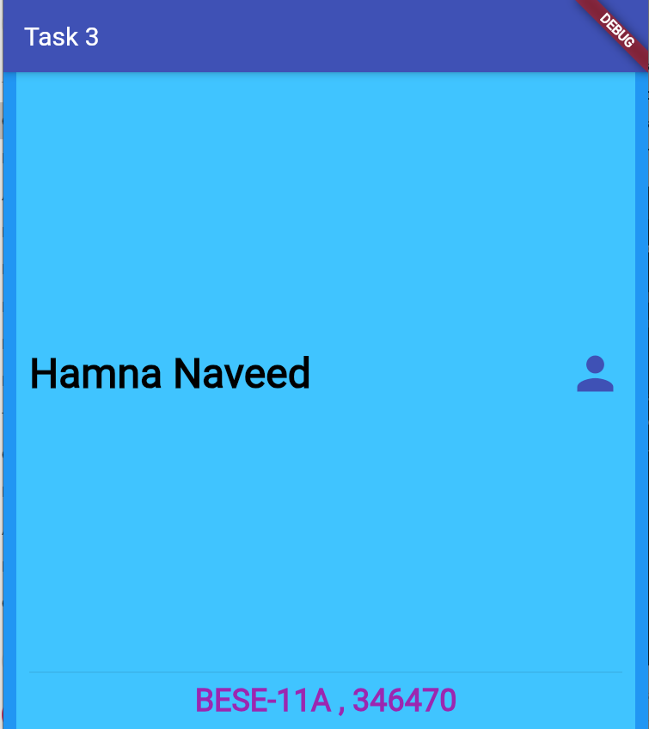

**GitHub Link**

**https://github.com/hamna456/Flutter-Lab-4/tree/main/task3**